DATA ANALYTICS WITH POWER BI
PROJECT REPORT
(Project Semester October-December 2025)

Wastewater Viral Surveillance Analysis Dashboard

Submitted by
Abhik Konar

Registration No. 12306328

Programme: B.Tech CSE
Section: K23BG
Course Code: INT374

Under the Guidance of
Vikas Mangotra
UID: 31488
Assistant professor

Discipline of CSE/IT
School of Computer science and Engineering
Lovely Professional University, Phagwara

DECLARATION

I, Abhik Konar student of Computer science and Engineering under CSE/IT Discipline at, Lovely Professional University, Punjab, hereby declare that all the information furnished in this project report is based on my own intensive work and is genuine.

Date: 12-12-2025 Signature: 
Registration No.: 12306328 Name of the student: Abhik Konar

CERTIFICATE

This is to certify that Abhik Konar bearing Registration no. 12306328 has completed INT374 project titled, “Wastewater Viral Surveillance Analysis Dashboard” under my guidance and supervision. To the best of my knowledge, the present work is the result of his original development, effort and study.

Signature and Name of the Supervisor
Designation of the Supervisor
School of Computer science and Engineering
Lovely Professional University
Phagwara, Punjab.

Date: 12-12-2025

Acknowledgement

I would like to express my sincere gratitude to my faculty, Vikas Mangotra, for her continuous guidance, valuable feedback, and consistent support throughout this project.
I would also like to thank Lovely Professional University for providing the resources and academic environment that allowed me to complete this project successfully.
Last but not least, I extend my thanks to my friends for their encouragement and support during the course of this work.
Abhik Konar

Table of Contents

Introduction 7
Source of Dataset 8
Dataset Preprocessing 9
3.1 Handling Missing Values
3.2 Data Cleaning
3.3 Feature Engineering
3.4 Merging Datasets
Analysis on Dataset 12
4.1 4.1 Total Records Overview
4.2 Average Population Served
4.3 Average Recovery Efficiency (%)
4.4 Geographic Distribution of Sampling Locations (Map View)
4.5 PCR Target Average Concentration by Year and Quarter
4.6 Flow Rate Distribution by Sample Type
4.7 Recovery Efficiency (%) by PCR Type
4.8 PCR Average Concentration by Counties Served
4.9 Flow Rate Distribution by Recovery Efficiency Spike Matrix
4.10 Increase vs Decrease in Viral Spike Concentration
4.11 Count of Sources by Sample Matrix
4.12 Daily Trend of lod_sewage by Year, Quarter, Month, and Day
4.13 Daily Count of Sample Types by Year, Quarter, Month, and Day
Conclusion 23
Future Scope 23
References 24

Introduction

Wastewater-based epidemiology (WBE) has emerged as a powerful public health surveillance method for monitoring viral activity within communities. Unlike clinical testing, wastewater monitoring captures viral signals from both symptomatic and asymptomatic individuals, offering an early and cost-effective indication of disease spread. This project, titled “Wastewater Viral Surveillance Dashboard,” focuses on analyzing and visualizing viral concentration trends using wastewater samples collected from various locations across the United States.
The primary objective of this project is to transform raw wastewater viral concentration data into meaningful and actionable insights. The dataset includes important parameters such as PCR target concentrations, recovery efficiency, sample collection methods, sample matrices, population served, and geographical distribution. By processing and analyzing these parameters, the dashboard provides a comprehensive view of viral presence and operational efficiency across different states, counties, and time periods.
This project uses Power BI to build an interactive dashboard that enables real-time visualization of key indicators, including temporal trends, geographical surveillance, sample processing effectiveness, and recovery efficiency comparisons. Through modern data visualization techniques, the dashboard helps identify hotspots, evaluate sampling methodologies, and understand changes in viral activity over time.
Overall, this system supports public health decision-making by delivering a centralized, user-friendly analytical interface. The results not only enhance epidemiological understanding but also demonstrate how data analytics and visualization can be effectively utilized to support large-scale viral surveillance programs such as those conducted by the CDC. This project highlights the importance of data-driven monitoring tools in strengthening preparedness and response strategies for future public health challenges.

Source of Dataset

The dataset used in this project was sourced from the Data.Gov, an open platform that provides real-world datasets .

Dataset Name: CDC_Wastewater_Data_for_Measles
Source Link: https://catalog.data.gov/dataset/cdc-wastewater-data-for-measles

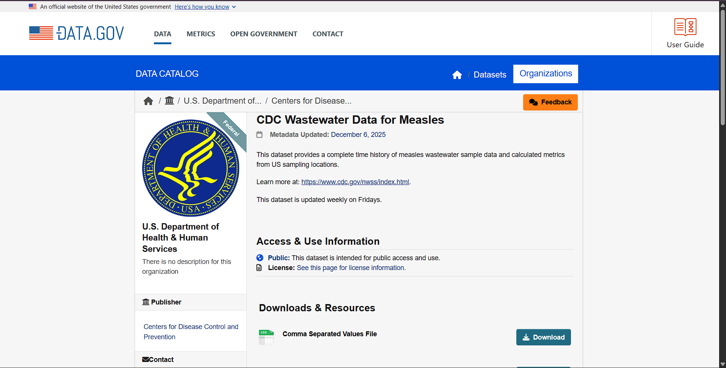

Dataset Preprocessing

Effective preprocessing is essential to ensure data quality, improve analytical accuracy, and support reliable visualization. The wastewater surveillance dataset contained a combination of numerical, categorical, and temporal variables collected from different sampling sites across the United States. The preprocessing steps included handling missing values, cleaning inconsistencies, engineering new features, and merging multiple data tables for unified analysis.

3.1 Handling Missing Values
Since the dataset is collected from various wastewater sampling facilities, missing values were common in fields such as recovery efficiency, PCR concentration, population served, and sample matrix details. The following strategies were applied:
-Identification of Missing Data
- Used Power BI’s Data View to locate blank, null, or erroneous entries.
- Filtered columns to visually inspect missing patterns.
- Imputation Strategy
- Numerical columns (e.g., pcr_target_avg_conc, rec_eff_percent):
  - Replaced missing values using mean or median, depending on skewness.
- Categorical columns (e.g., sample_type, sample_matrix):
  - Replaced with most frequent value (mode).
- Time-related fields:
  - Missing months or dates were corrected by deriving values from available timestamps.
-Removal of Unusable Records
- Records with extensive missing values across critical fields were removed to maintain dataset integrity.
- Duplicate entries were identified and deleted.
3.2 Data Cleaning
Cleaning ensures that the dataset is consistent, standardized, and ready for analysis.
-Data Type Correction
- Converted date fields to Date/Time format.
- Converted numeric values stored as text into whole number or decimal formats.
- Standardization of Categorical Values
- Unified inconsistent labels such as:
  - “raw sample,” “raw wastewater sample,” and “raw” → Raw Sample
  - “grab” and “grab sample” → Grab Sample
- Ensured consistent naming for PCR types (ddPCR, qPCR, etc.).
- Outlier Detection & Treatment
- Inspected extreme values in concentration fields.
- Outliers due to reporting errors or unit mismatches were corrected or removed.
- Removal of Unnecessary Columns
- Eliminated fields not relevant to analysis (metadata, empty IDs, unused flags).

3.3 Feature Engineering
New features were derived to enhance analytical insights.
- Date-Based Features
- Extracted Year, Month, and Quarter from sample collection timestamps.
- Created time hierarchies to enable trend analysis.
- Performance Metrics
- Created calculated fields such as:
  - PCR Target Average Concentration
  - Recovery Efficiency Category (High, Moderate, Low)
  - Population Category (Small, Medium, Large service areas)
- Aggregation Features
- Created groupings for:
  - Sampling method types
  - Sample matrix categories
  - Viral target names
These engineered features helped enrich the dashboards with more meaningful comparisons.

3.4 Merging Datasets
If multiple files were provided (e.g., sampling data, laboratory results, population data), merging was required.
- Consolidation Process
- Imported all datasets into Power BI.
- Used Power Query Editor to merge queries using:
  - Site ID
  - Sampling date
  - PCR target name
- Join Logic
- Left Join was used to preserve all sampling records.
- Additional supplementary tables were appended using Append Queries where necessary.
- Final Unified Table
- The merged dataset provided a single, clean data model that supported:
  - Time-series analysis
  - Geographical comparisons
  - Sampling method evaluation
  - Recovery efficiency analysis

Analysis on Dataset
4.1 Total Records
i. General Description
This card represents the total number of wastewater surveillance entries available in the dataset, summarizing overall data volume.
ii. Specific Requirements
- Display total number of records collected.
- Show dataset size clearly for readers.
iii. Analysis Results
The dashboard shows 22K total records, indicating a large, diverse dataset supporting reliable analysis and trend identification.
iv. Visualization
A simple summary card displaying the total number of entries (22K).

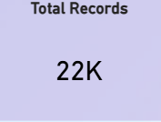
4.2 Average Population Served
i. General Description
This chart highlights the average number of people served by the wastewater treatment facilities being monitored.
ii. Specific Requirements
- Calculate mean population served across all facilities.
- Display minimum and maximum population served.

iii. Analysis Results
The average population served is 218.52K, showing that the monitoring system covers large communities. Values range from 0 to 437.04K.
iv. Visualization
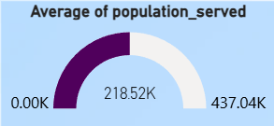

4.3 Average Recovery Efficiency (%)
i. General Description
Recovery efficiency (%) indicates how effectively viral material is captured during sampling and processing.
ii. Specific Requirements
- Compute mean recovery efficiency across all samples.
- Compare efficiency against expected range.

iii. Analysis Results
The average recovery efficiency is 87.02%, indicating highly effective viral recovery, supporting reliable detection accuracy across samples.
iv. Visualization
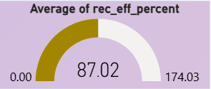

4.4 Map of Sampling Locations
i. General Description
A geographic overview of states participating in wastewater surveillance.
ii. Specific Requirements
- Identify states contributing samples.
- Show sampling density using color intensity.

iii. Analysis Results
The map highlights multiple states across the U.S., with darker shades representing higher data contributions, suggesting uneven but widespread sampling coverage.
iv. Visualization
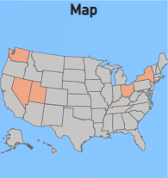

4.5 PCR Target Avg Concentration by Year and Quarter
i. General Description
This line chart tracks how viral concentration changes over time across quarters and years.
ii. Specific Requirements
- Aggregate PCR target average concentration by quarter.
- Identify rising or falling trends.

iii. Analysis Results
The plot shows a strong upward trend from 0.00M in Oct 2024 to 0.89M in Oct 2025. Major increases appear in April and July 2025, indicating possible surges or improved detection.
iv. Visualization
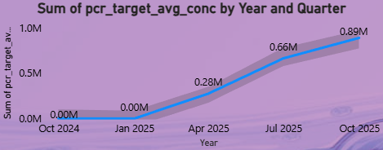
4.6 Flow Rate by Sample Type
i. General Description
This bar chart shows distribution of sample collection methods based on their flow rate.
ii. Specific Requirements
- Sum flow_rate by sample_type.
- Identify dominant sampling methods.

iii. Analysis Results
The 24-hr flow-weighted sample method has the highest flow rate (38.39K), followed by grab samples (7.71K), indicating that long-duration composite sampling is preferred.

iv. Visualization

Interpretation: The pie chart illustrates the various reasons why music playback sessions ended. The largest portion of the chart is occupied by the “trackdone” category, indicating that a significant majority of tracks were listened to completely without interruption. This suggests consistent user engagement with the content and a tendency to let songs play through to the end.
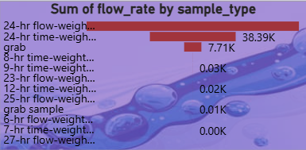

  - Recovery Efficiency (%) by PCR Type
- General Description
This visualization compares recovery efficiency across various PCR platforms.
ii. Specific Requirements
- Compute average rec_eff_percent by PCR type.
- Identify which PCR method performs best.
iiiAnalysis Results
ddPCR shows the highest efficiency (101%), while other PCR types like qPCR or Qiagen-based PCR show lower efficiency values.
iv. Visualization
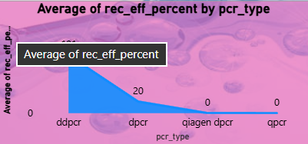

4.8 PCR Avg Concentration by Counties Served
i. General Description
This chart shows how different counties contribute to overall viral concentration.
ii. Specific Requirements
- Aggregate PCR target concentration by county.
- Identify high-contribution counties.
iii. Analysis Results
Grand Traverse County has the highest contribution (0.22M), followed by Olmsted and Maui. This reflects higher sampling frequency or larger treatment capacity.
iv. Visualization

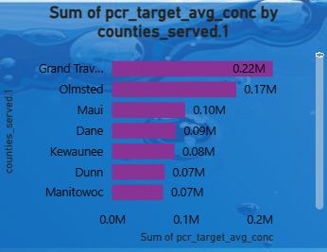
4.9 Flow Rate by Recovery Efficiency Spike Matrix
i. General Description
A donut chart that shows how flow rate varies across different sample processing (spike matrix) conditions.
ii. Specific Requirements
- Sum flow_rate based on rec_eff_spike_matrix category.
- Identify most commonly used matrix type.
iii. Analysis Results
“Clarified sample” dominates with 81.52K (57.71%), indicating that most samples undergo clarification to improve detection reliability.
iv. Visualization
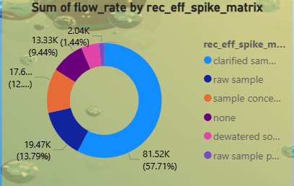

4.10 Increase vs Decrease in Recovery Efficiency Spike Concentration
i. General Description
This comparison chart indicates how viral spike concentrations have increased or decreased.
ii. Specific Requirements
- Compare different viral targets.
- Highlight positive or negative changes.
iii. Analysis Results
There is a significant increase in bcov vaccine concentration, whereas other targets show reduced or minimal changes, indicating targeted fluctuations.
iv. Visualization
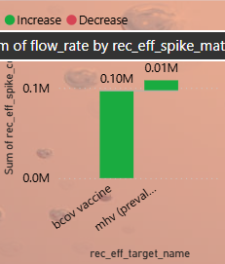
4.11 Count of Sources by Sample Matrix
i. General Description
This pie chart shows the distribution of sample matrices contributing to surveillance.
ii. Specific Requirements
- Count number of samples per matrix type.
- Identify most common sample matrix.
iii. Analysis Results
The post-grit sample matrix is the most common (around 29%), followed by raw wastewater, reflecting typical sampling points in treatment plants.
iv. Visualization
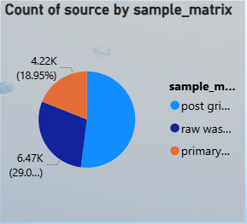
4.12 Sum of lod_sewage by Year, Quarter, Month, and Day
i. General Description
This visualization shows the daily trend of lod_sewage values over time, capturing fluctuations in sewage load. It helps identify changes in wastewater volume and potential factors affecting inflow patterns such as rainfall, population activity, or seasonal shifts.
ii. Specific Requirements
- Aggregate lod_sewage by year, quarter, month, and day.
- Identify long-term and short-term spikes in sewage load.
- Observe seasonal or periodic patterns.
- Detect periods of increased wastewater inflow that may influence viral concentration levels.
iii. Analysis Results
The data shows minimal sewage load in early 2025, followed by a significant rise starting from June 2025.
Daily fluctuations become very strong from August to November 2025, with recurring peaks reaching 1.9M to nearly 2.0M lod_sewage.
This pattern suggests:
- High inflow variability during late monsoon and early winter months.
- Regular weekly cycles, likely linked to population movement or facility operations.
- Nearly zero sewage load at earlier months indicates either data unavailability or low sampling activity.
iv. Visualization
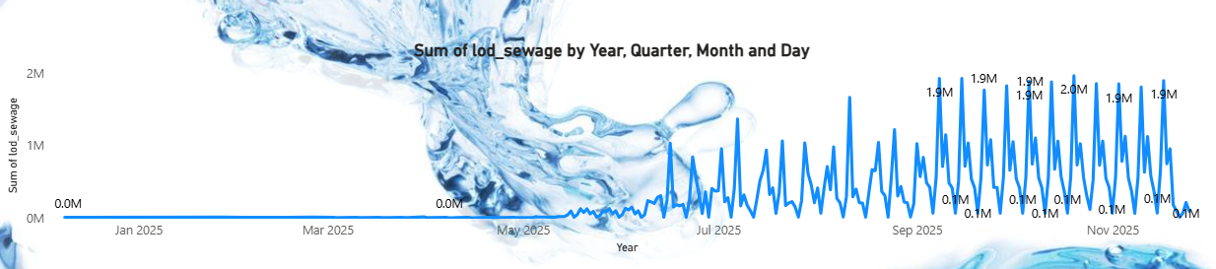

4.13 Count of sample_type by Year, Quarter, Month, and Day
i. General Description
This visualization represents how many sample types were collected on each day across different time periods. It helps measure sampling frequency and consistency across months.
ii. Specific Requirements
- Count number of samples collected each day.
- Identify sampling intensity across time.
- Detect patterns in data collection such as weekly cycles or seasonal increases.
- Compare periods of high vs low sampling activity.
iii. Analysis Results
Sampling counts remain minimal until March 2025, after which they begin increasing gradually.
A major surge occurs from July 2025, showing clear periodic spikes, with daily counts frequently reaching 228, 236, 243, and 246 samples during peak periods.
Key findings:
- Sampling becomes consistent and highly intensive from August–November 2025.
- Regular peaks suggest structured weekly or operational sampling schedules.
- Early months show very low sampling numbers (5–10 samples/day), indicating initialization phases or limited facility participation.
iv. Visualization
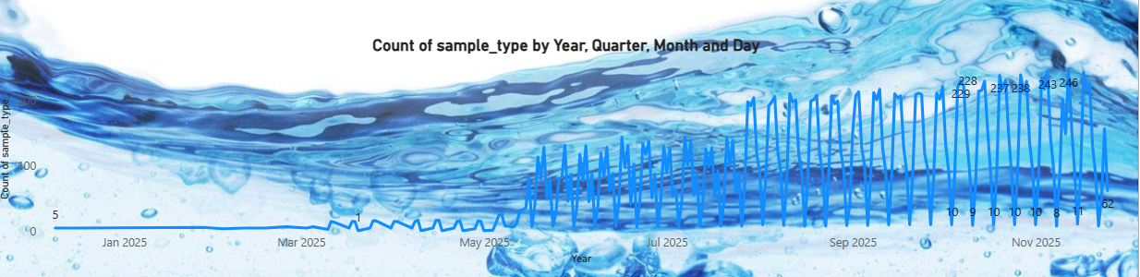

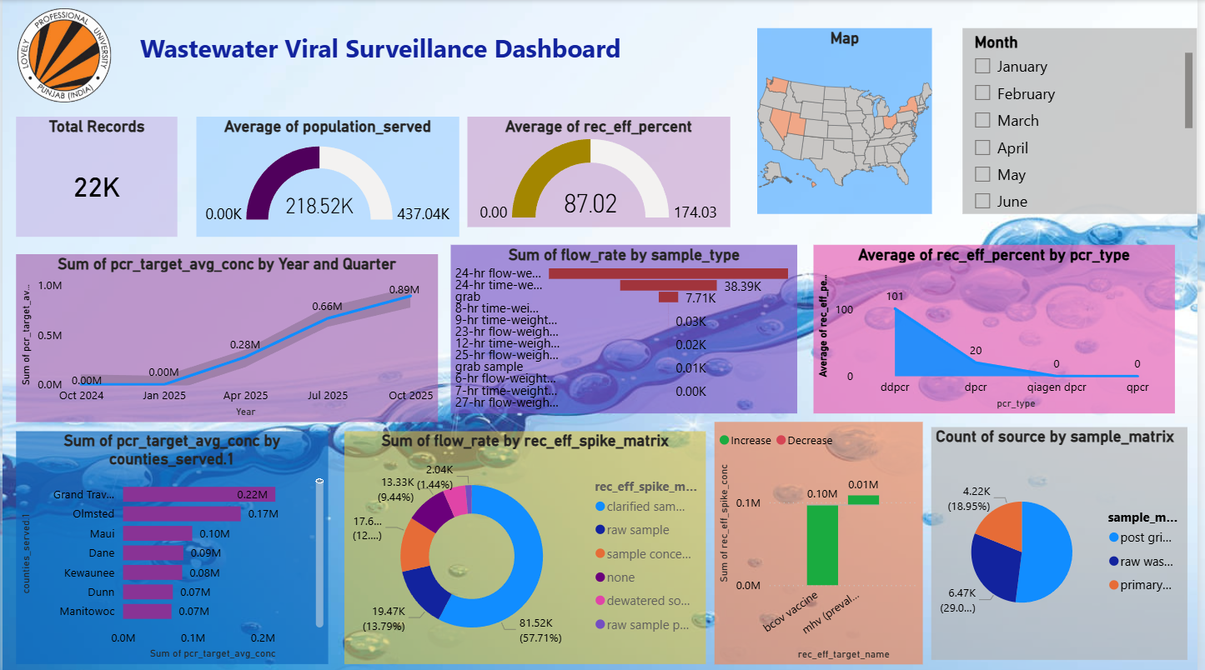
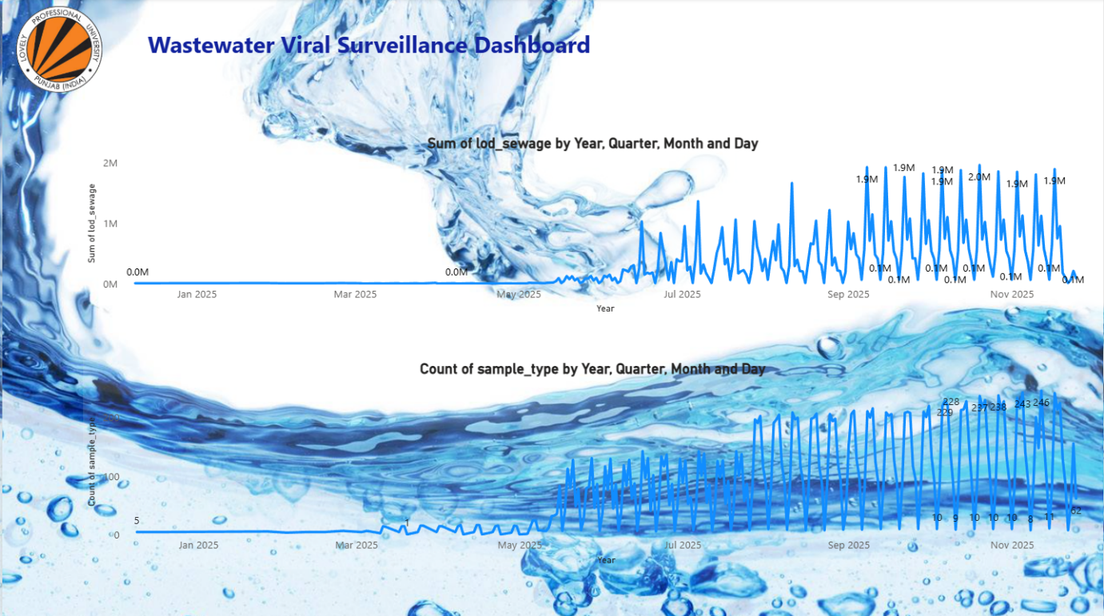

Conclusion
The Wastewater Viral Surveillance Dashboard successfully demonstrates the power of data analytics and visualization in supporting public health surveillance. By processing wastewater samples from multiple states and counties, the system provides a comprehensive overview of viral activity, sample quality, and recovery efficiency across different time periods and geographical locations.
Through structured preprocessing, feature engineering, and interactive visualizations, the dashboard transforms raw environmental data into meaningful insights. Key indicators such as PCR target concentrations, recovery efficiency, sample matrix distribution, and sampling methodology performance were effectively analyzed to identify patterns and highlight operational variations.
The integration of Power BI enabled the creation of an intuitive interface where trends, anomalies, and geographic hotspots can be easily explored. This contributes to better decision-making for public health authorities, helping them understand viral prevalence, compare sampling approaches, and evaluate surveillance effectiveness in real time.
Overall, the project highlights the critical role of wastewater-based epidemiology in early disease detection and the importance of analytical tools in enhancing public health monitoring. The dashboard provides a scalable solution that can be extended to include more pathogens, larger datasets, and predictive analytics, strengthening preparedness for future public health challenges.

Future Scope

The dashboard can be enhanced by integrating machine learning–based predictive analytics, enabling early detection of rising viral concentrations and providing real-time outbreak forecasts to support faster and more effective public health decision-making.

References

- Centers for Disease Control and Prevention (CDC). National Wastewater Surveillance System (NWSS) Dataset.
Available at: https://data.cdc.gov
- Data.gov. Wastewater and Environmental Surveillance Datasets.
Available at: https://catalog.data.gov
- U.S. Department of Health & Human Services (HHS). Wastewater-Based Epidemiology Resources.
Available at: https://www.hhs.gov
- World Health Organization (WHO). Environmental Surveillance and Public Health Guidelines.
Available at: https://www.who.int
- Power BI Documentation. Data Modeling, Cleaning, and Visualization.
Microsoft Learn. Available at: https://learn.microsoft.com/power-bi
- Radoi, V., & Huisman, J. Wastewater-Based Monitoring of Viral Pathogens: A Review.
Journal of Environmental Health Science & Engineering, 2021.
- Peccia, J. et al. Measurement of SARS-CoV-2 RNA in Wastewater Tracks Community Infection Dynamics.
Nature Biotechnology, 2020.

